PARKS, FORESTRY & RECREATION

Ourland Community Centre
18 Ourland Ave.
416-394-8673

Co-Ed Older Adult Volleyball
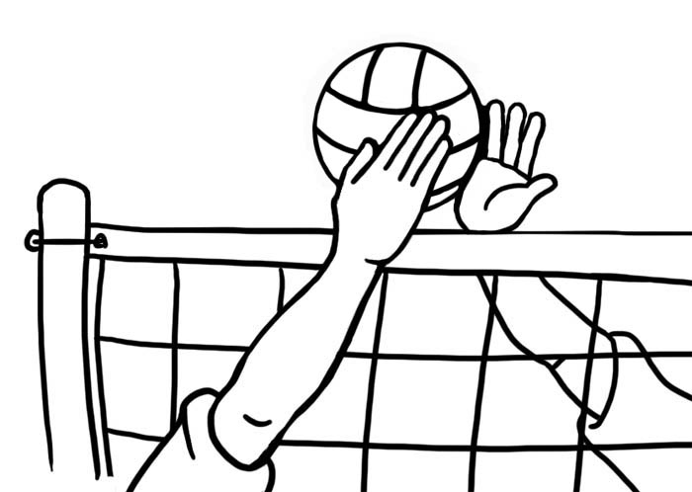

Day: | Thursdays
Time: | 1:00 – 3:00 pm
 | FREE / Drop-In 10 weeks
Date: | Starts October 13, 2022

Whether you are an experienced player or just looking to try something active and meet new people, drop by and play volleyball on one of our two courts.

For more information call Ourland C.C. at 416-394-8673
at 416-394-8673

